
Elections of deputies
to Local Councils of Deputies
of the Republic of Belarus
of the 27th Convocation
Monitoring Report on the registration of campaign teams and candidates for deputies
The observation is carried out by activists of RHRPA “Belarusian Helsinki Committee” and the Human Rights Center "Viasna" within the frames of the campaign "Human Rights Defenders for Free Elections". 29 long-term observers of the campaign "Human Rights Defenders for Free Elections" were involved in the observation.
KEY FINDINGS

Observers worked without significant obstacles, but the procedures for verification of signatures and other documents submitted for registration of candidates still lacked transparency. 100 % of observers of the campaign “Human Rights Defenders for Free Elections” were not allowed to attend such checks and had no opportunity to witness the commissions’ complete and unbiased approach to reviewing the documents. Observers could only attend meetings, where results of the checks were voiced and decisions on registration were taken. This significantly reduces the credibility of the work of the election commissions, allows to question not only individual decisions to refuse the registration of candidates, but also the decisions to register candidates.
Opportunities for observation were slightly improved after several changes were introduced by the CEC’s Regulation “On the Procedure of Delegating Observers in the Preparation and Conduct of Elections.” The CEC agreed to the proposal of human rights defenders, political parties and other national public associations to allow observers to attend meetings of election commissions and polling stations.
According to the CEC, 22,338 candidates were registered, or 98.81 % of the number of nominated representatives. The same percentage of registration was in the previous elections to the local councils. Analysis of the practice and statistics suggests that verification procedures were used selectively by the election commissions, primarily against opposition candidates.
- LEGAL FRAMEWORK
An Act of November 25, 2013 amended the Electoral Code rules on nomination of candidates and candidate registration. In particular, according to the new version of the Code’s Article 60, a citizen has the right to stand as a candidate for deputy in only one constituency. Previously, there was no such restriction, and some potential candidates used the opportunity to be nominated in several districts to work with voters.
In accordance with Art. 60 of the EC, the right to nominate candidates for deputies of local councils by collecting signatures belongs to political parties, labor collectives and citizens. Political parties may nominate candidates for deputies of local councils only having registered organizational structures. Nomination of candidates for deputies of respective councils is carried out by labor collectives located in respective territories. Collection of signatures is carried out by a campaign team in an amount of 3 to 10 people. The person proposed for nomination as a candidate for deputy should be supported by voters residing in the territory of the electoral district in the amount of: for the Regional Council and the Minsk City Council of Deputies – not less than 150; for the District, City (cities of regional subordination) Council of Deputies – not less than 75; and for the Town (towns of regional subordination) and Village Council of Deputies – not less than 20 persons.
Collection of signatures can be carried out in the form of picketing. No permission is needed to arrange picketing if it is held in places that are not prohibited by local executive and administrative bodies.
Any person can sign in support of the nomination of the proposed persons provided he or she has the right to vote, i.e. is a citizen of Belarus who has attained 18 years of age. Voters have the right to sign in support of several candidates, but only once in support of the same candidate.
Participation of administrations in collecting signatures, as well as coercion in the process of collecting signatures and reward to voters for signatures is not allowed. Applicants for a candidate’s status are not eligible to involve their subordinates in the implementation of activities promoting nomination in the working hours. Violation of these requirements may be grounds for refusal of registration of a candidate. Signature sheets shall be submitted to the respective DEC for verification of voters’ signatures and registration of candidates.
Procedures for the registration of candidates were also amended to improve technical aspects. Electoral legislation has not yet resolved the right of observers to be attend the verification of signatures and the authenticity of other documents provided for registration. Given that one of the reasons for refusal of registration of candidates is inaccuracies in collected signatures for nomination and other documents, monitoring the compliance of procedures of verification with the requirements of the EC appears to be extremely relevant.
Procedures for the verification of signatures by the DECs are regulated by Art. 67 of the EC. The main requirement is that the check is exposed to cover at least 20 % of the number of voters’ signatures required for registration of a candidate. If the number of invalid signatures of voters found during the inspection exceeds 15 % of the number of verified signatures, an additional check is performed for another 15 % of the entire number of voters’ signatures required for registration of a candidate. If the total number of invalid signatures identified during verification exceeds 15 % of the total number of verified signatures on signature sheets, no further verification of signatures is carried out. Verification of the validity of signatures in signature sheets is carried out in the manner prescribed by Par. 15, 16, 18 and 19 of Art. 61 of the EC.

- REGISTRATION OF CAMPAIGN TEAMS
In accordance with the timetable, submission of applications for registration of campaign teams and lists of members of campaign teams to the respective election commissions took place in the period from 12 to 16 January, 2014. According to the CEC, during this period, the commissions received 16,066 applications. Among those nominated for candidates to deputies by collecting signatures, 98.1 % are non-partisans. And only 1.9 % are members of political parties.
Registration of campaign teams and issuing certificates and signature sheets to members of campaign teams were held within five days from the date of receipt of applications. The CEC reported that 99.7 % of the campaign teams were registered. Figures show that the election commissions mostly did not create obstacles to the registration of campaign teams except for the cases of nominees filing applications for registration of campaign teams in several constituencies.
Election commissions actively used the 2013 amendment that allows a candidate to be nominated in only one constituency. If the nominee had applied for registration of campaign teams in several constituencies, the DECs ruled to deny the registration of all his campaign teams. Such decisions, for example, affected Deputy Chairman of the National Human Rights and Educational NGO “Movement For Freedom” Ales Lahviniets, BPF Chairman Aliaksei Yanukevich, Chairman of the United Civil Party Anatol Liabedzka and others.
This approach, according to experts of the campaign “Human Rights Defenders for Free Elections”, is too restrictive and contrary to the electoral law. Decisions to deny registration to the campaign teams of a candidate who had submitted applications for several constituencies generally deprived the candidate of an opportunity to run in the elections. However, the EC, as suggested by an analysis of the provision, prohibits nominating in more than one constituency. Therefore, it would be legitimate to register a candidate in the first constituency, where he tried to stand.
It should be noted that the CEC did not give any guidelines on the application of the new rule, which caused ambiguous treatment by those involved in the campaign and create a negative practice limiting the ability of opposition candidates to be nominated.
As a result, most failures in the registration of campaign teams were reported by candidates from opposition parties. The UCP had filed 50 applications, 39 of them were granted (22 % denials). The BPF Party had filed 50 applications, 40 were granted (20 % denials). Meanwhile, the registration of campaign teams in support of non-party candidates for deputies resulted in a significantly lower amount of denials – only 0.1 %.
An interesting incident took place during the registration of a campaign teams of Mikalai Ulasevich. The CEC’s decision of January 21, 2014 overturned a decision by the Astrovets District Election Commission to allow registration of Mikalai Ulasevich’s campaign teams for nominating him to run for the District Council in two constituencies. It should be noted that according to Art. 33 of the EC, the CEC is entitled to cancel the decision of a lower commission and issue its own decisions relating to the competence of a lower commission. But in this case it is not possible to appeal against the decision in court. In particular, the Supreme Court refused to consider a complaint by Mikalai Ulasevich against the CEC’s actions referring to lack of jurisdiction to hear the case. The Supreme Court once again expressed its position that the CEC’s decisions can be appealed only in cases stipulated by the EC. Experts of the campaign “Human Rights Defenders for Free Elections” regard it as a denial of the right to a fair trial guaranteed by Art. 60 of the Constitution and Art. 14 of the International Covenant on Civil and Political Rights.
Political parties used collection of signatures as a means of nomination, since the parties’ nomination opportunities are limited by the need to have a registered office in the region. Another significant motive for nomination by voters’ signatures was the fact that the collection of signatures provides an additional opportunity to communicate with voters and campaign for the future candidate.

- COLLECTION AND VERIFICATION OF SIGNATURES FOR THE NOMINATION OF CANDIDATES FOR DEPUTIES
Local authorities had selected places prohibited for picketing for the purpose of collecting signatures. These included central squares and streets, locations within 50 meters from the executive committees’ buildings, public transport and so on. Places allowed for picketing to collect signatures, according to observers, were mostly poorly populated or inconvenient. However, campaign activists collected signatures in places not allowed by local authorities. Local governments were relatively liberal towards such activities held in Hrodna, Homel and Mahiliou.
Observers of the campaign “Human Rights Defenders for Free Elections” reported that at the stage of collecting signatures there were cases of obstacles from the authorities. In particular, a member of a campaign team of Aleh Shabetnik representing the “Tell the Truth” campaign in Karavatsichy constituency No. 35 (the Rechitsa District Council), was threatened with dismissal from the post of an accountant at a local farm. On the day after a rally in support of a UCP candidate, Dyana Kastsiukovichy, Chairman of the UCP’s Brest regional office, Uladzimir Vuyek, received a subpoena saying he should come to the police station and give explanations on the picket.
Procedures for verifying signatures and other documents submitted for registration still lacked transparency. 100 % of the campaign observers were not allowed to attend such checks and had no opportunity to witness the commissions’ complete and unbiased approach to reviewing the documents. Observers could only attend meetings, where results of the checks were voiced and decisions on registration were taken. This significantly reduces the credibility of the work of the election commissions, allows to question not only individual decisions to refuse the registration of candidates, but also the decisions to register candidates.
At the same time, opportunities for observation were slightly improved after several changes were introduced by the CEC’s Regulation “On the Procedure of Delegating Observers in the Preparation and Conduct of Elections.” The CEC agreed to the proposal of human rights defenders, political parties and other national public associations to allow observers to attend meetings of election commissions and polling stations.
On February 13, an observer of the campaign “Human Rights Defenders for Free Elections” in Baranavichy, Siarhei Housha, received a reply to his statement signed by the Chair of Baranavichy City DEC, Tamara Shukala. It said that the observer could not attend the verification of signatures for candidates Ryhor Hryk and Viktar Tsiapin. The election commission Chair refers to Art. 13 of the EC and adds that “the observer has no right to interfere in the work of the commission”. Siarhei Housha notes that Article 13 of the EC provides for open and transparent elections, so he considers his claim legitimate.
Approach to checking the documents for registration of candidates was not unbiased and equitable. In particular, election commissions invalidated the signatures collected for the nomination of each of the nine activists of the campaign “Tell the Truth”, Vitsebsk coordinator of the movement “For Freedom” Khrystafor Zhaliapau, and coordinator of the organizing committee of the BCD Tatsiana Seviarynets, who wanted to run for the Vitsebsk City Council, as some of their supporters allegedly failed to write the date in person. The activists argue that the signatures were collected in full compliance with the procedures, and their supporters were pressured or their statements were received through deception. Some of them appealed against the decision to refuse registration. Party members were able to register by party nominations.
Pavel Levinau, a human rights defender in Vitsebsk, says he does not trust the actions of a local election commission: “I submitted exactly 75 signatures as required by law. All of them are valid, and moreover, everyone who signed up for me filled a special statement in case there was a check, that they put their signatures in their own hand. I also took these statements to the commission. However, I was told that there was one woman who testified that she did not write the date”. The members of Pavel Levinau’s campaign team discovered that the “confession” the election officials received from the woman was fraudulent. Pavel Levinau is appealing the commission’s decision.
Members of the Bykhau DEC interviewed voters to inquire why they put their signatures for the nomination of a BPF activist, Siarhei Antonau, for the Mahiliou Regional Council. Such “polls” are not included in the functional responsibilities of the DEC members and are a disguised form of pressure on voters. According to Siarhei Antonau, other voters were not interviewed about the pro-government candidates (director of “Belatmit”, Barys Tsyporyn, and director of the company “Hrudzinauski food plant”, Vital Kavalenka).
Most of the nominees and their campaign teams, observers say, were not active in the process of checking the documents for registration, often not even present at the meetings of the commissions that approved their registration.
- RESULTS OF NOMINATION OF CANDIDATES FOR DEPUTIES OF LOCAL COUNCILS OF DEPUTIES
A total of 22,784 persons were nominated as candidates for deputies of Local Councils of Deputies, including by collecting signatures – 14,215, or 62.4 % of the total number of nominations, from labor collectives – 6,876 (30.2 %), by political parties – 705 (3.1 %). As compared to the elections to the local councils in 2010, the number of nominees was reduced by 10 %. In comparison with the previous elections, the number of candidates nominated by political parties increased by 27 %. Still, their part is still insignificant. Labor collectives remain active participants in the campaign. They nominated nearly a third of the candidates. Such a high level of political activity is not typical for groups formed on production or business grounds, especially in today’s difficult economic situation.
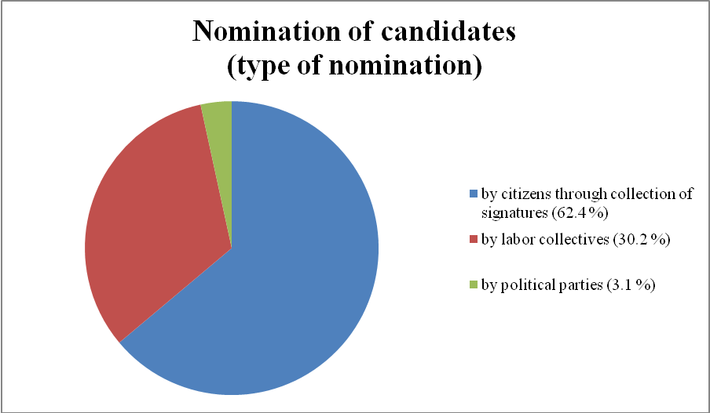
10 of the 15 registered political parties nominated their candidates for deputies of Local Councils of Deputies.
Most nominations were submitted by the Communist Party of Belarus (277 candidates or 34.1 % of the total number nominated by political parties), the Belarusian Left Party “Fair World” (119 candidates or 14.6 %), the United Civil Party (111 candidates or 13.6 %).
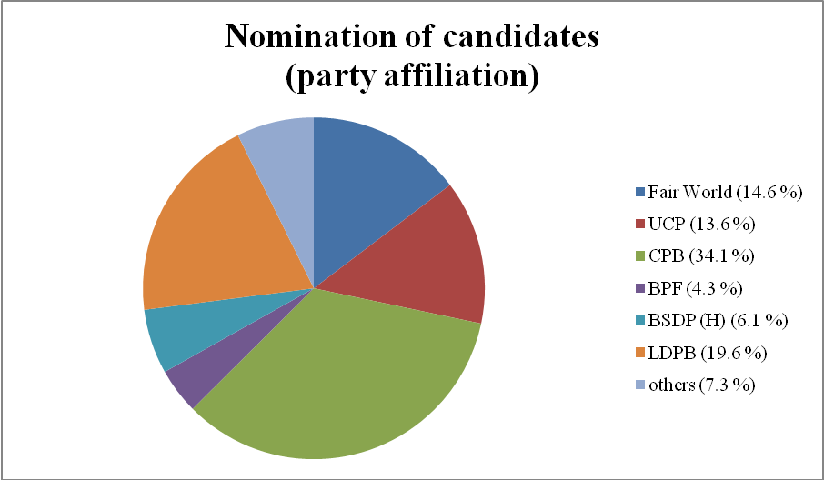
- RESULTS OF REGISTRATION OF CANDIDATES FOR DEPUTIES OF LOCAL COUNCIL OF DEPUTIES
In accordance with the timetable, registration of candidates by election commissions was held from 11 to 20 February, 2014 inclusive.
According to the CEC, 22,338 candidates were registered, representing 98.81 % of the number of nominated candidates. The same percentage of registration was reported in the previous elections to the local councils. 14,931 registered candidates were nominated by signature collection, which is 66.8 % of the total number; 7,727 candidates were nominated by labor collectives (34.6 %), 675 candidates were nominated by political parties (3 %).
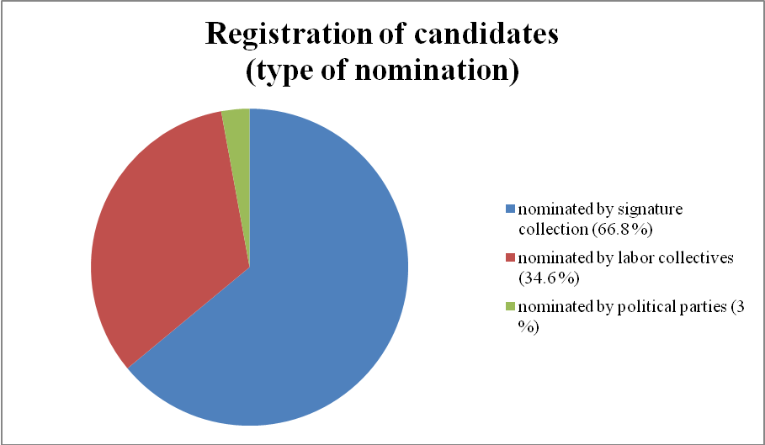
The number of registered candidates from pro-government political parties is larger than that of the opposition parties. In particular, four opposition parties nominated 315 candidates, of whom 238 were registered, which is about 75 % of the total number of nominated candidates. At the same time, the average percentage of the registration of candidates from the pro-government parties amounted to 88 % of the number of nominated representatives. The number of registered candidates from the Communist Party of Belarus amounted to 92 %, the Republican Party of Labor and Justice – 94 %. Election commissions registered 100 % of applicants from the Belarusian Patriotic Party and the Belarusian Social and Sports Party.
Proportion of registered candidates
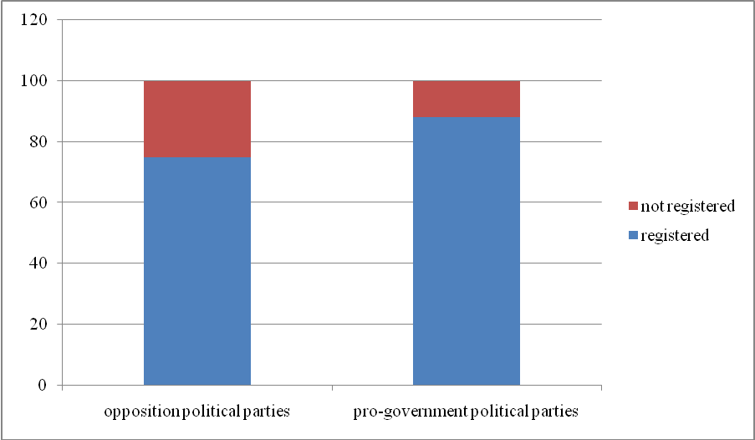
Proportion of registered candidates from separate parties
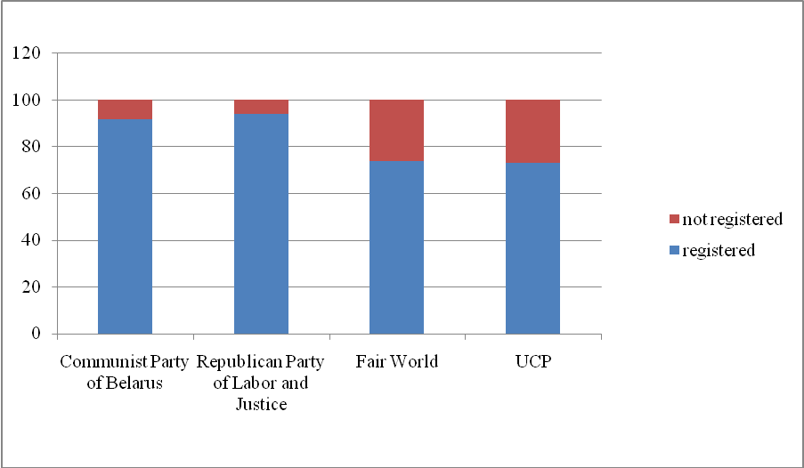
Apparent is the difference in approaches to the opposition representatives who were nominated by signature collection. While the total percentage of registration of candidates by collecting of signatures was 98 %, the proportion for the nominees of the unregistered BCD party is 32%, and for the representatives of the “Movement for Freedom” – 43 %.
Proportion of registered candidates from the number of nominated representatives (by signature collection)
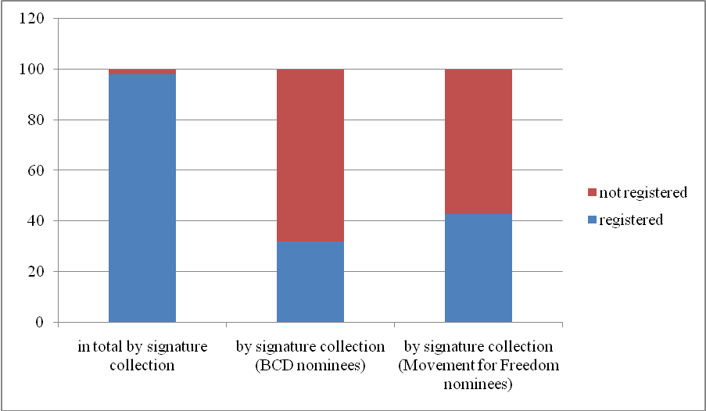
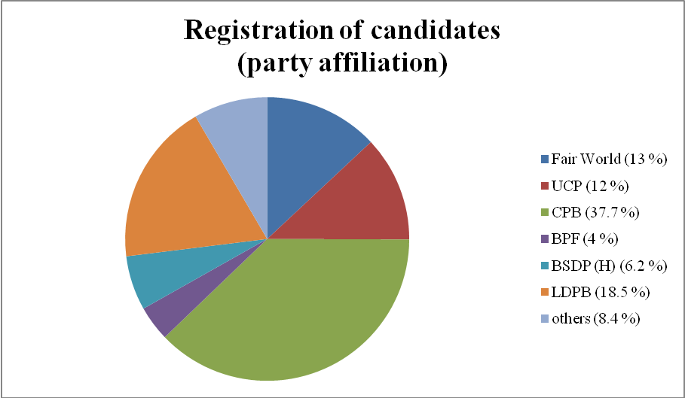
Analysis of the CEC data on the results of the registration of candidates allows to draw interesting conclusions. It is known that traditionally political activity is most concentrated in the capital: the contest of nominations for the Minsk City Council was 4.74 candidates for a seat, while competition for the district councils was 1.29, and in rural councils – 1.12. Representatives of both the opposition and pro-government parties were nominated primarily in Minsk. Few of them are running to the regional councils, while elections to the village councils will virtually have no party members.
84 persons representing political parties will be running in the 57 constituencies of the Minsk City Council, and in 3,913 constituencies of the district councils there are 134 candidates from parties, and 58 party candidates in the 13,638 constituencies of the rural councils.
Statistics of refusals of registration and withdrawals of applications for nomination allow to see the level of political intensity, as well as the scope of use of technical procedures for registration (verification of signatures, declarations, etc.) in the political struggle. In particular, the number of refusals to register candidates for the Minsk City Council was 25.6 %, at the district council level – 1.9 %, in rural councils – 0.2 %. The difference in quality of documents submitted for registration cannot be explained by the level of training of candidates running for the councils of lower levels as compared to the experienced party members and activists running in the capital. Experts of the campaign “Human Rights Defenders for Free Elections” believe that the review of documents and registration of candidates by the election commissions was accompanied by a selective use of technical procedures.

Republican public association “Belarusian Helsinki Committee”: http://belhelcom.org/docs; Human Rights Center «Viasna»: http://spring96.org/.
Regulation “On the procedure for sending observers in the preparation and conduct of elections to the local councils of the Republic of Belarus of the twenty-seventh convocation and re-election of a deputy of the House of Representatives of the National Assembly of the Republic of Belarus of the fifth convocation in the Homel Navabelitskaya constituency No. 36.”
http://www.rec.gov.by/sites/default/files/pdf/Elections-MS27-sved16.pdf.
Act of November 25, 2013 No. 72-Z “On Amendments and Additions to Some Laws of the Republic of Belarus on elections and referenda”
According to Art. 4 of the EC, right to participate in the elections is denied to citizens found legally incapable under a court sentence, persons detained in prison, as well as those for which custody was selected as the measure of restraint. Art. 58 of the EC entitles citizens of the Russian Federation permanently residing in the Republic of Belarus to participate in elections to the local councils.
Calendar plan of arrangements for the preparation and conduct of elections to the local councils of the Republic of Belarus the twenty-seventh convocation. http://www.rec.gov.by/sites/default/files/pdf/Elections-MS27-kalend.pdf
http://www.rec.gov.by/sites/default/files/pdf/Elections-MS27-sved6.pdf
http://www.rec.gov.by/sites/default/files/pdf/Elections-MS27-sved11.pdf
spring96.org/en/news/69260
http://www.rec.gov.by/sites/default/files/pdf/Elections-MS27-sved16.pdf
The first column shows the CEC data, the second – information from the BCD, the third – according to the “Movement for Freedom”

